Painting/Illustration Lines

Curved, thin, hard

Straight, thick hard

Straight, thin, soft

Jagged, soft, thin

Curved, thin, hard

Thick, hard, straight

Statue

Straight, thin, hard

Straight, thick, hard

Straight, thin, soft

Thick to thin, curved, hard to soft

Graphic Image

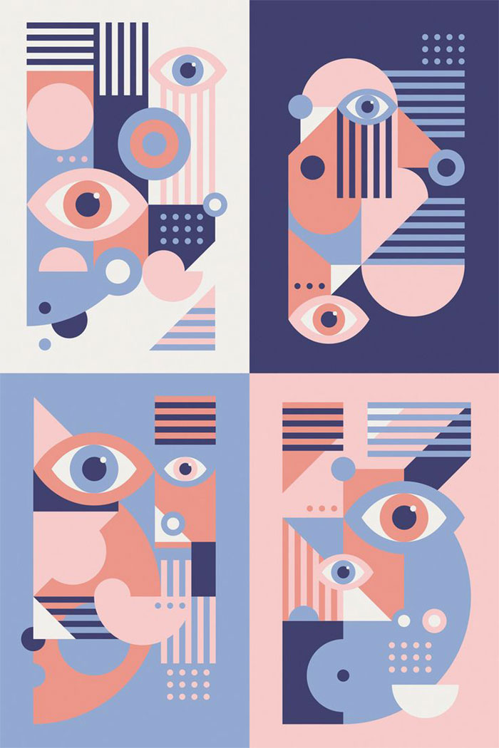

Curved, thin, hard

Straight thin, soft

Curved thin soft

Straight thick hard

Photography

Thick

Hard

Straight

Straight, thin, soft

Straight, thin, hard

Curved, thin, soft